Intelligent Ambulance – AI and Human Interface Technology

Increasing population is a big concern for today’s developing India as it’s require huge resources to provide basic facilities which includes education and health system. India already suffering from availability of less medical resources which causes death to peoples suffering from risky diseases related to heart, brain, kidney etc. Due to increasing population we can see dense traffic jam at all developing cities which becoming major hurdle for ambulance to reach hospital on time and this traffic jam may cause death to the patient.

To reduced such loss we are employing AI based Ambulance system which will have direct communication with patient’s vitals and hospital server to report patient condition to doctors so doctor’s will take necessary precautions before patient arrival to provide require medication on time.

IOT sensors will read patient vitals and then using internet connection will report vitals to hospital servers and then AI algorithm will receive VITALS and then predict patient condition and if condition abnormal then it will alert doctors to arrange necessary medications.

To implement this project we have trained AI algorithms such as Random Forest, Decision Tree and KNN and this trained algorithm will predict patient conditions from test. All algorithms trained on HEART disease dataset available on KAGGLE data repository.

We have evaluated each algorithm performance in terms of accuracy, precision, recall, confusion matrix and FSCORE and in all algorithms Random Forest and Decision Tree giving an accuracy up to 100%.

To implement this project we have designed two applications such as

1. Hospital: this application will load, preprocess dataset and then trained all algorithms on processed data and then start cloud server to receive request from Ambulance
2. Ambulance: we don’t have any IOT sensors so we are uploading test data from file as Patient Vitals and then this application will report test data to Hospital server which will predict patient condition and send response back to ambulance

SCREENSHOTS

First double click on ‘run.bat’ file from Hospital folder to start hospital application to train all AI algorithms and will get below output

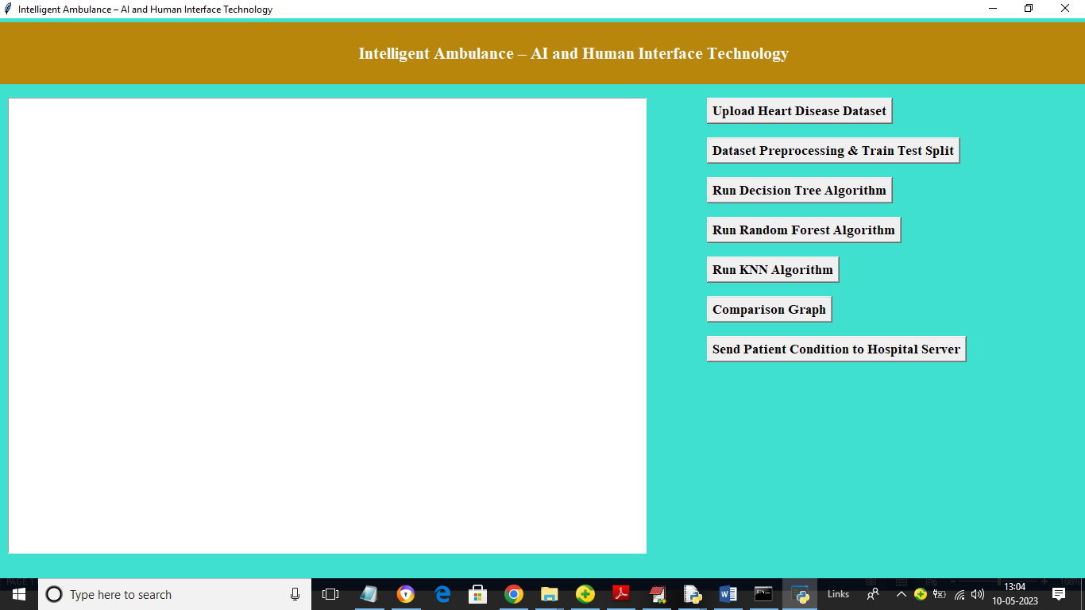

In above screen click on ‘Upload Heart Disease Dataset’ button to upload dataset and get below output

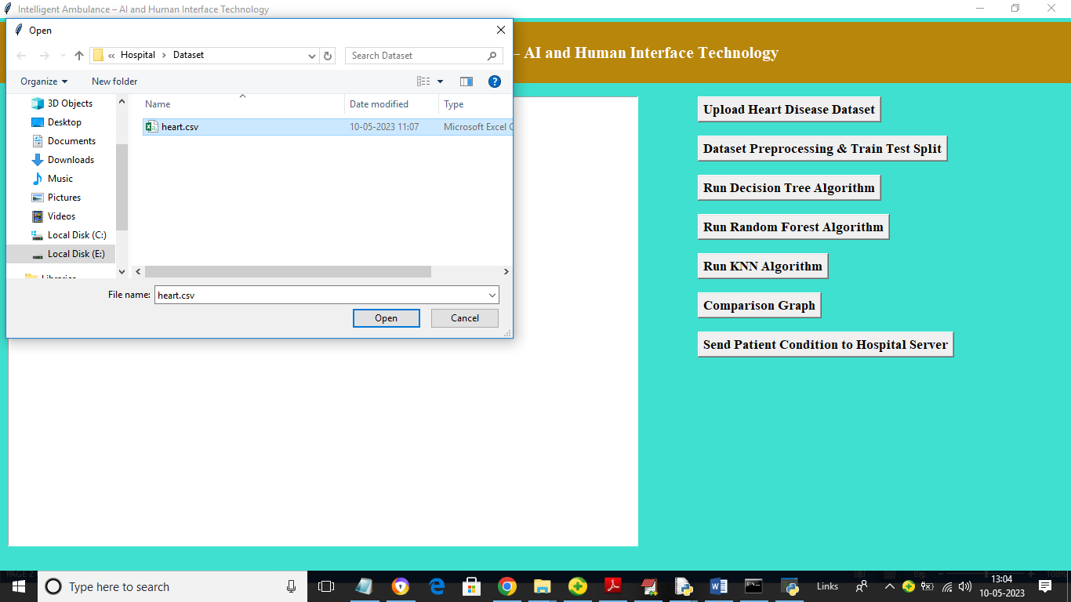

In above screen selecting and uploading dataset ‘heart.csv’ file and then click on ‘Open’ button to get below output

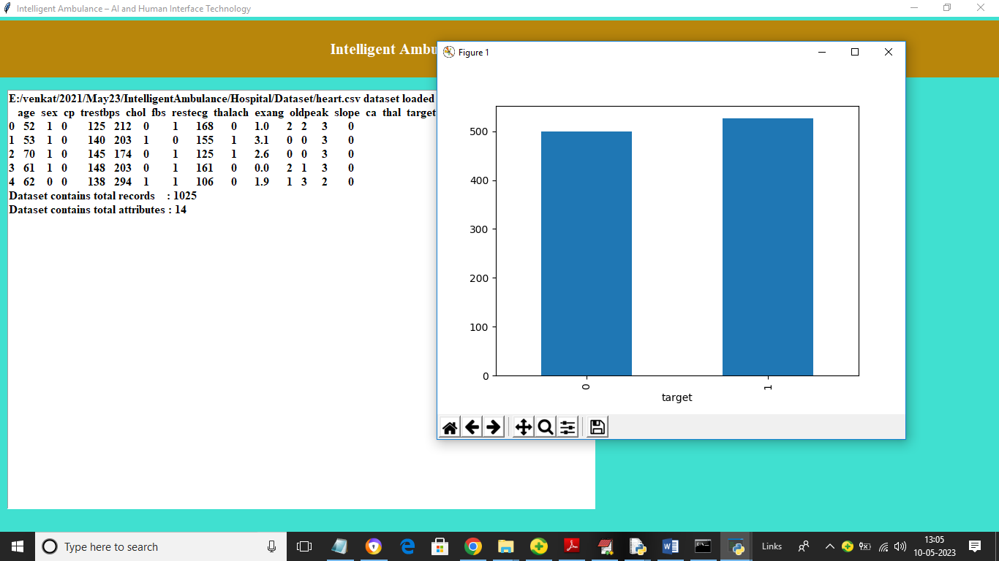

In above screen dataset loaded and in graph x-axis represents class labels as 0 (normal) and 1(abnormal) and y-axis represents count of dataset records and now close above graph and then click on ‘Dataset Preprocessing & Train Test Split’ button to preprocess dataset such as shuffling, normalizing and splitting dataset into train and test

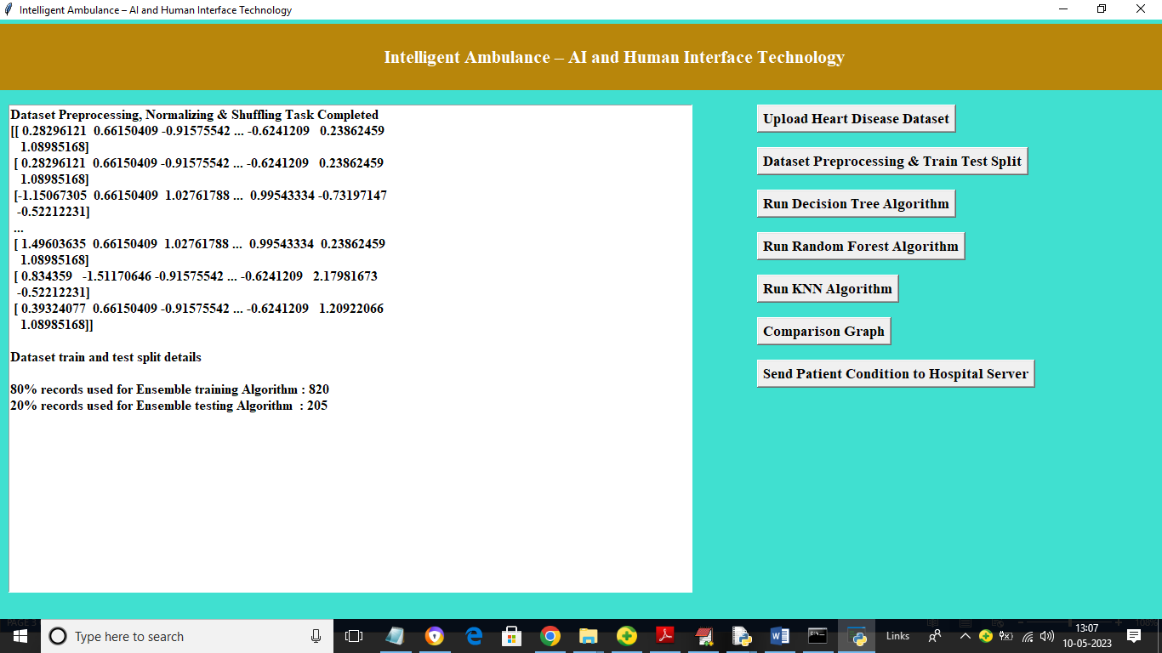

In above screen dataset is processed and we can see 80% dataset used to train algorithms and 20% to test algorithms accuracy and now click on ‘Run Decision Tree Algorithm’ button to train decision tree and get below output

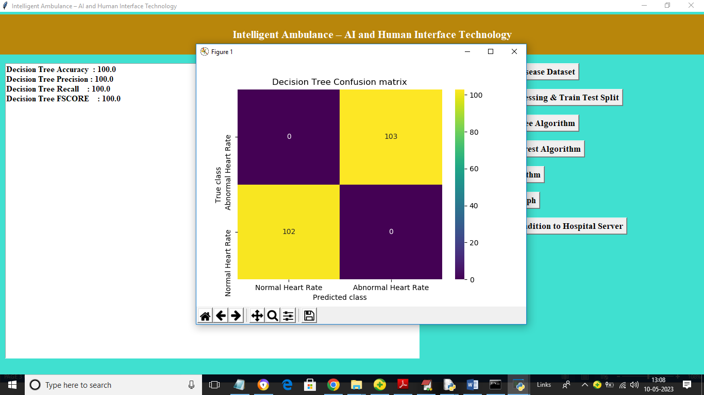

In above screen decision tree training completed and we got its accuracy as 100% and we can see other metrics and in confusion matrix graph x-axis represents Predicted Labels and y-axis represents True Labels and yellow boxes contains correct prediction count and blue boxes contains incorrect prediction count and now close above graph and then click on ‘Run Random Forest Algorithm’ button to train Random Forest and get below output

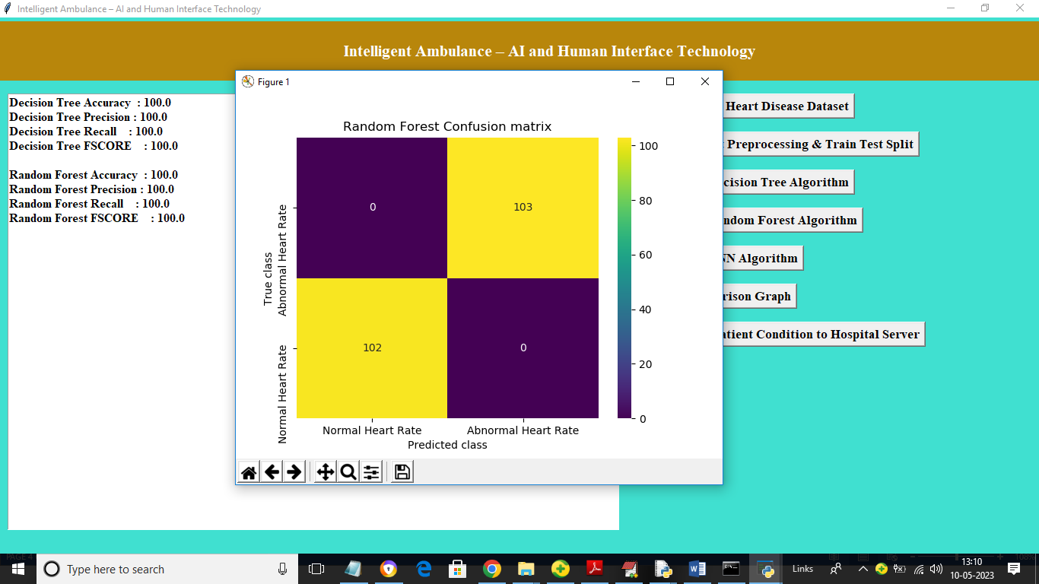

In above screen Random Forest also got 100% accuracy and now click on ‘Run KNN Algorithm’ button to train KNN and get below output

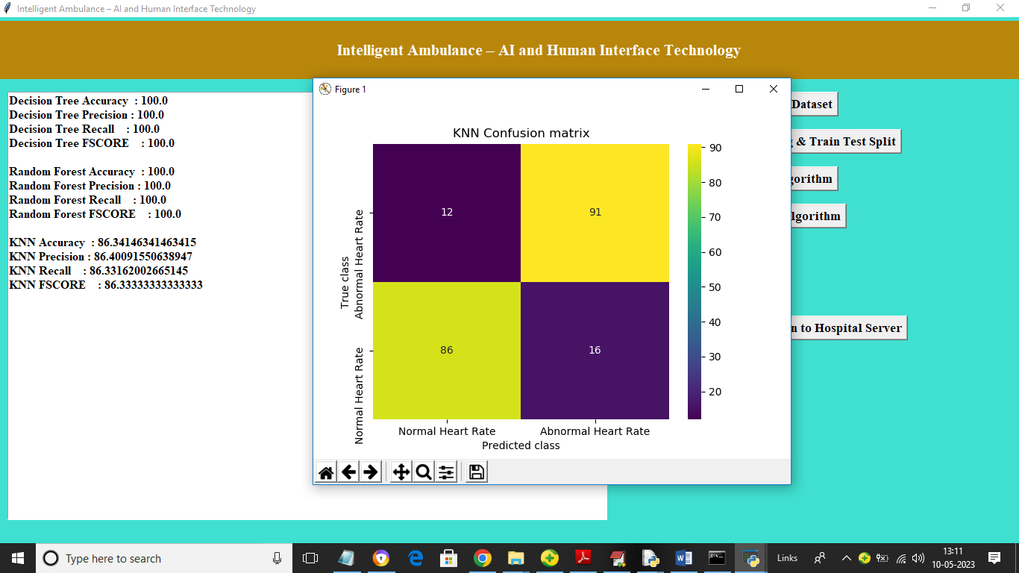

In above screen with KNN we got 86% accuracy and now click on ‘Comparison Graph’ button to get below graph

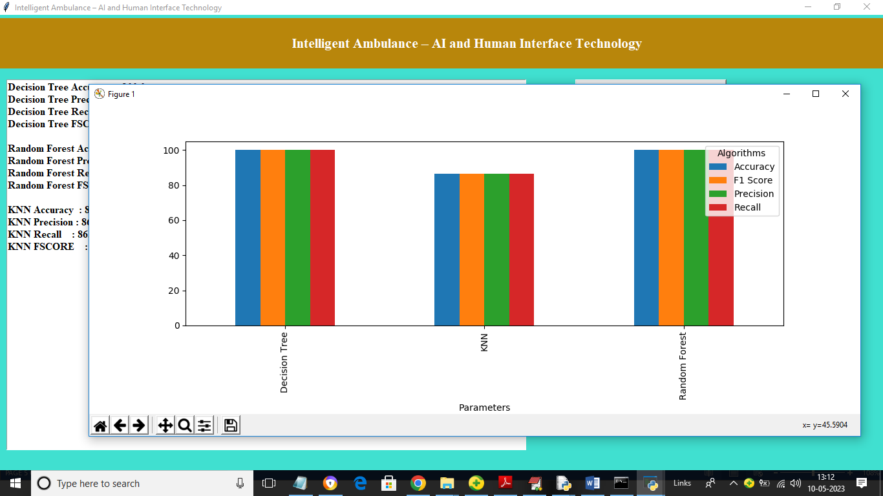

In above graph x-axis represents algorithm names and y-axis represents accuracy and other metrics in different colour bars and in all algorithms Decision tree and random forest got high accuracy and now click on ‘Receive Patient Condition to Hospital Server’ to start hospital cloud server and get below output

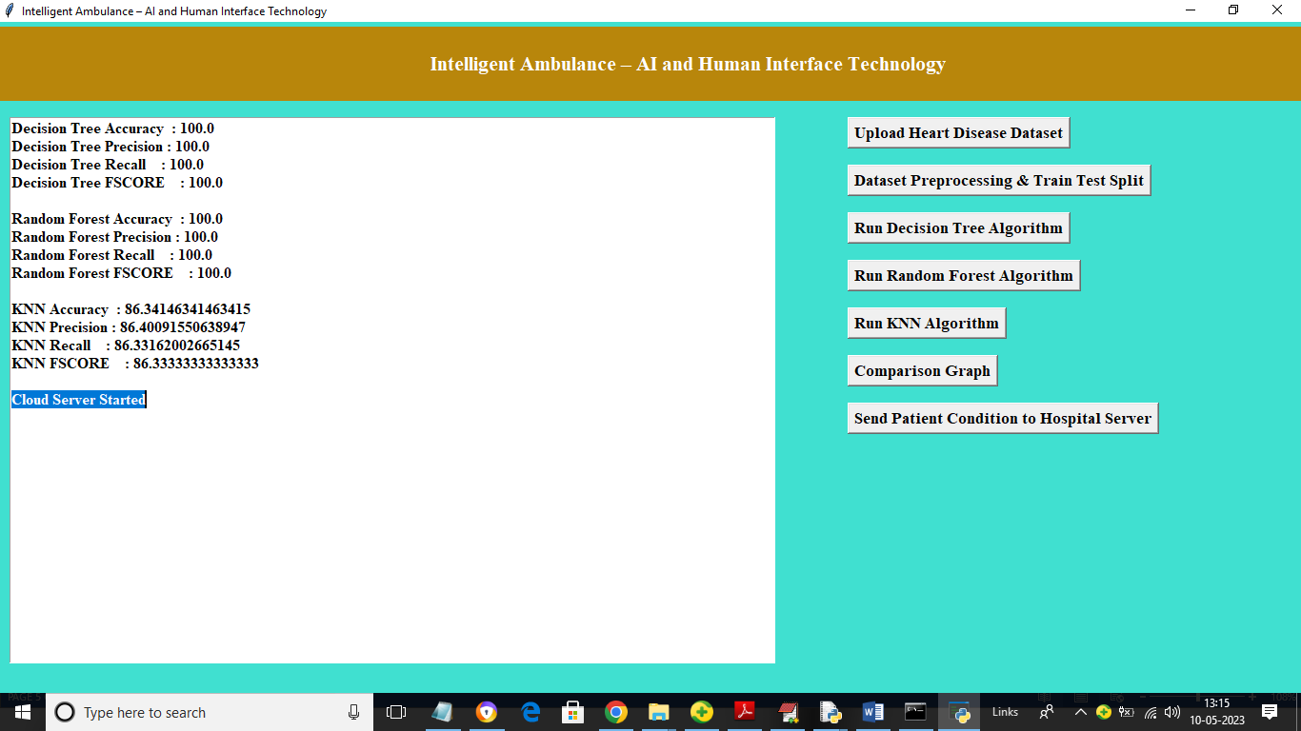

In above screen in blue line we can see hospital server started and now start Ambulance application by double click on ‘run.bat’ file from ‘Ambulance’ folder to get below screen

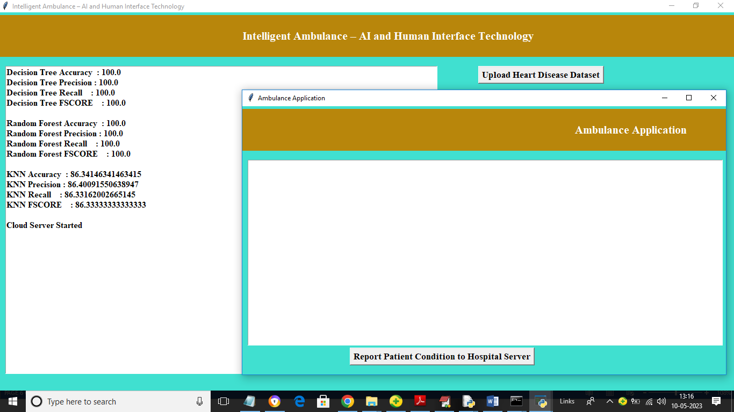

In above screen click on ‘Report Patient Condition to Hospital server’ button to upload test data file and then ambulance will send data to server to get patient predicted output

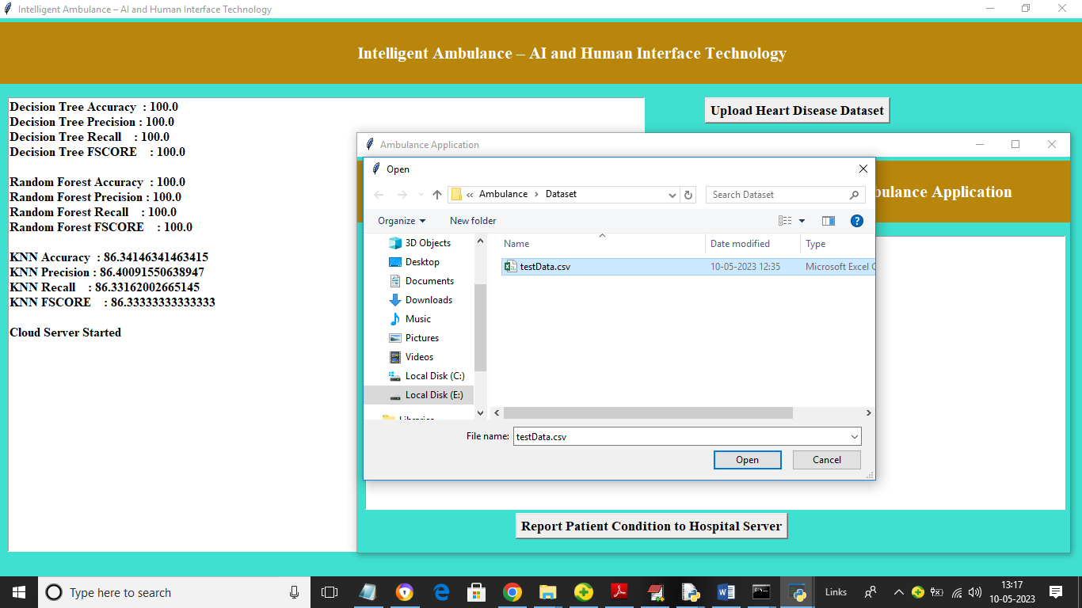

In above screen selecting and uploading ‘testData.csv’ file and then click on ‘Open’ button to load test data and get below output

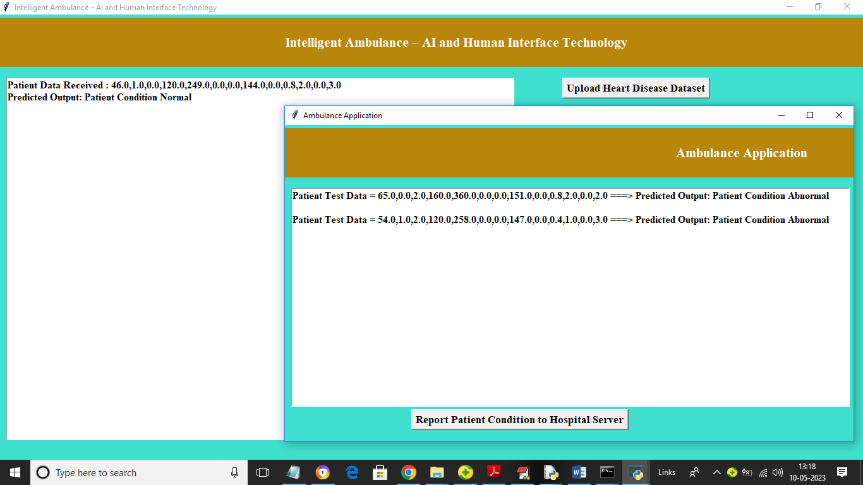

In above screen ambulance sending test data and then server receiving patient data and then predicting condition as normal and abnormal and sending back response to ambulance

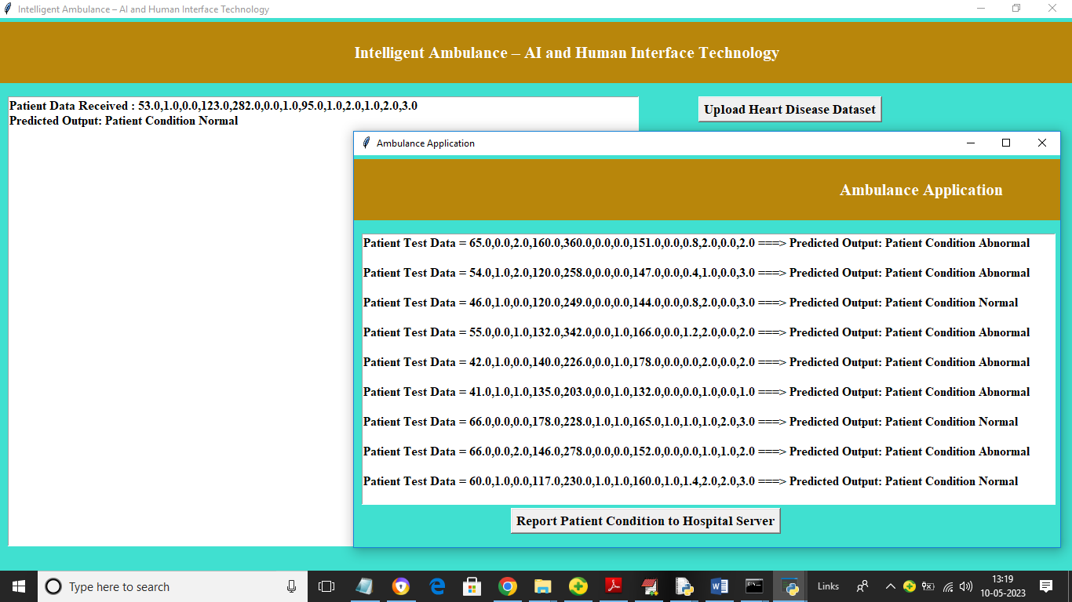

In above screen continuously ambulance will send patient data to server to get predicted condition and based on condition doctors will arrange medications